**FIIT FORMATION PRIVATE LIMITED**

**No 1545, 1st floor, Near Anna Arch, Vellore main road**

**Vengikkal , Tiruvannamalai**

**Project Name: Amazon Laptop sales Dashboard**

**Tutor: Ashok Kumar sir**

**Date: 24/03/2025, Monday**

**Agenda**

**Introduction ----------------------------------------------- 1**

**Overview of Dashboard ------------------------------------ 2**

**Benefits of Dashboard -------------------------------------- 3**

**Technologies used ------------------------------------------- 4**

**Dashboards ------------------------------------------ 5,6,7,8,9**

**Conclusion ------------------------------------------------- 10**

**Introduction**

**Amazon Laptop sales Dashboard**

* **A Amazon Laptop sales Dashboard offer a comprehensive the laptop sales performance across the amazon platform**
* **It is great way to connect with Data analyst , PowerBI developer , PowerBI architect to learn the slicers , performance analysis , analyzing market trends, Customer ratings, pricing trends and user can interactive easily**
* **This project involved building Designed Dashboards**
* **In project we can analysis current sales , trends , stock analysis and other requirements**
* **This tool provide the clarity needed to smart , Data-driven decisions**

**Overview of Dashboard**

**Amazon Laptop Sales Dashboard**

* **The Amazon Laptop sales Dashboard is an interactive PowerBI dashboard that visualizes key metrics related to laptop sales on the amazon platform**
* **It is designed to help user understand sales performance and make informed decision with real-time data**
* **Dashboard Highlights**
* **Sales performance: Unit sold, average selling price**
* **Top brands & Models : Identify the most popular laptop brands**
* **Customer insights : Analyze average ratings , customer satisfaction**
* **Price distribution: How laptop are performing across the India**

**Benefits of Dashboard**

**Amazon Laptop sales dashboard**

**list of benefits of the Amazon Laptop Sales Dashboard:**

**✅ Benefits of the Amazon Laptop Sales Dashboard**

1. **Data-Driven Decision Making  
   Get clear, visual insights into sales performance, customer behavior, and product trends to make smarter business decisions.**
2. **Real-Time Performance Tracking  
   Monitor sales, revenue, and customer feedback in real time, enabling quick responses to market shifts.**
3. **Identify Best-Selling Products  
   Easily spot top-performing laptop brands and models to focus marketing and inventory efforts.**
4. **Understand Customer Preferences  
   Analyze customer ratings and reviews to improve product listings and enhance customer satisfaction.**
5. **Optimize Pricing Strategy  
   Use price segmentation insights to align pricing with customer demand and maximize profitability.**
6. **User-Friendly & Interactive  
   Interactive filters and visuals make it easy to explore the data from different angles—no technical skills required.**
7. **Improved Inventory Management  
   Anticipate high-demand products and plan stock levels more accurately, reducing overstock and stockouts.**

**Technologies used**

**Amazon Laptop sales dashboard**

1. **Microsoft Power BI**
   1. **Used to design interactive dashboards and visualizations.**
   2. **Supports dynamic filtering, slicers, drill-downs, and responsive visuals.**
2. **Power Query (M Language)**
   1. **For data cleaning, transformation, and loading from various sources.**
   2. **Helps shape raw data into an analysis-ready format.**
3. **Excel / CSV Data Source *(or optional SQL Database)***
   1. **Sales data was imported from structured sources like Excel or CSV files**
4. **Amazon Product Dataset** 
   1. **Data includes product name, brand, price, ratings, reviews, and sales figures.**

**Amazon laptop sales dashboards**

* **Amazon Laptop sales on Excel workbook**

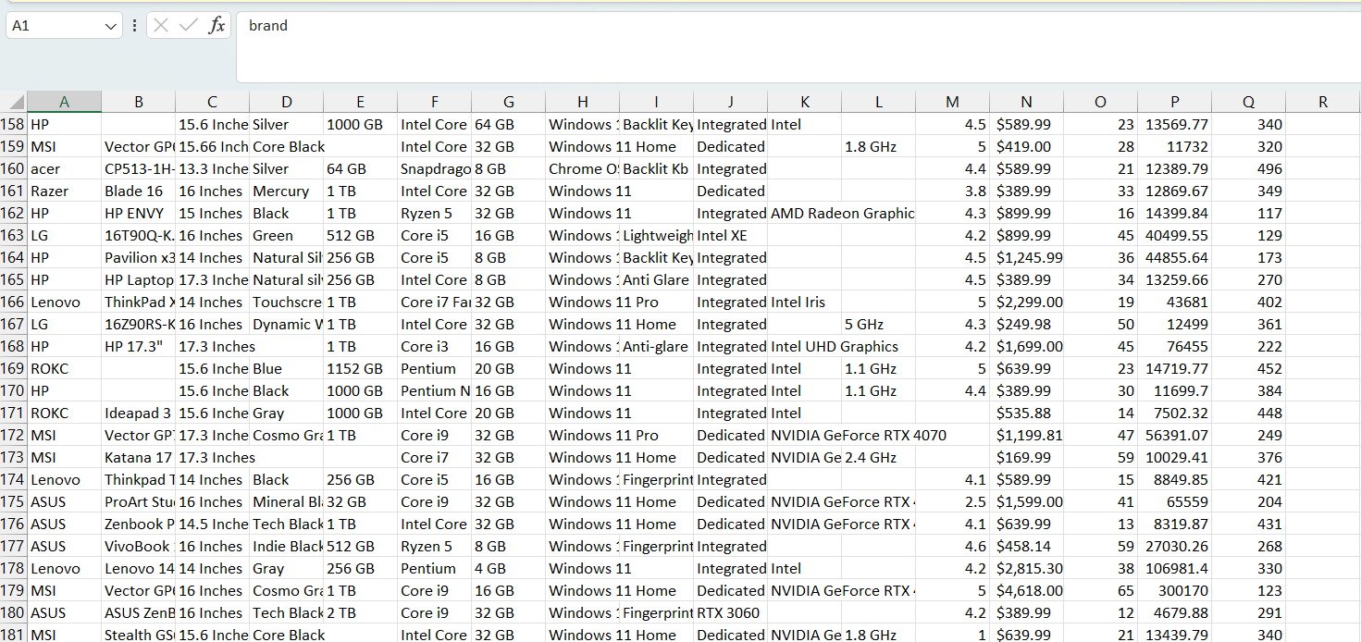

**Import Excel workbook transform to Power query editor**

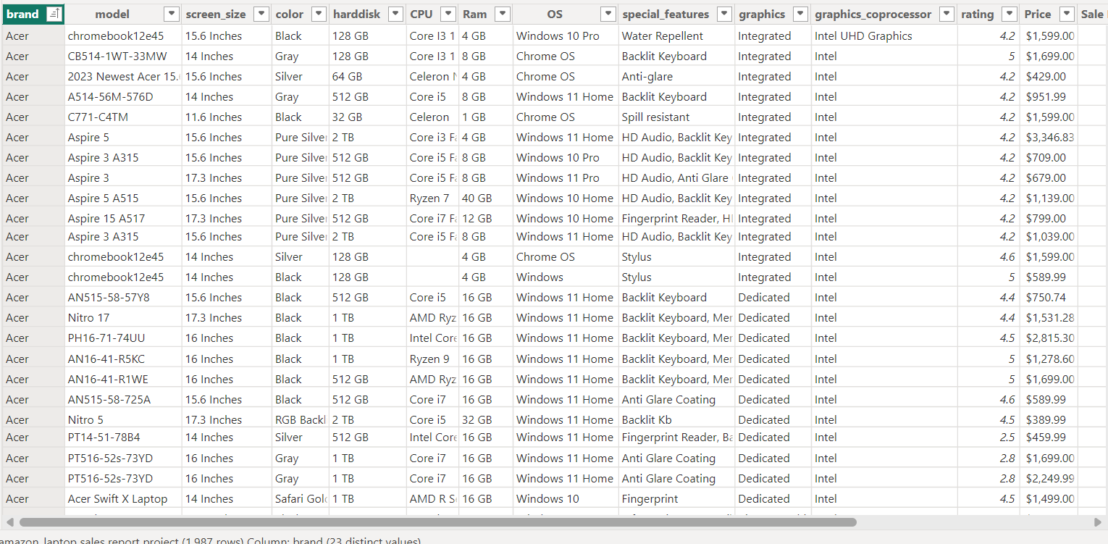

**Check the data, cleaning the data and checking the missing values, duplicate values and making Interactive Dashboard**

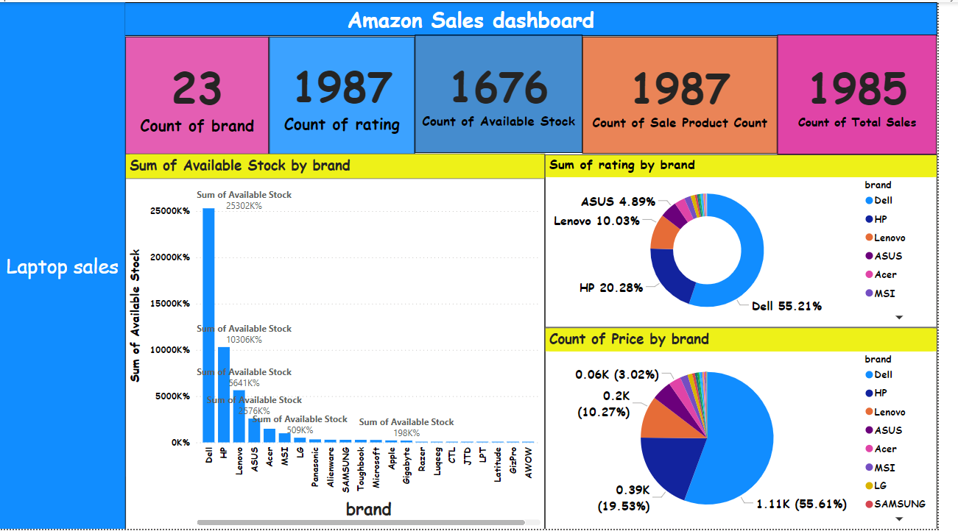

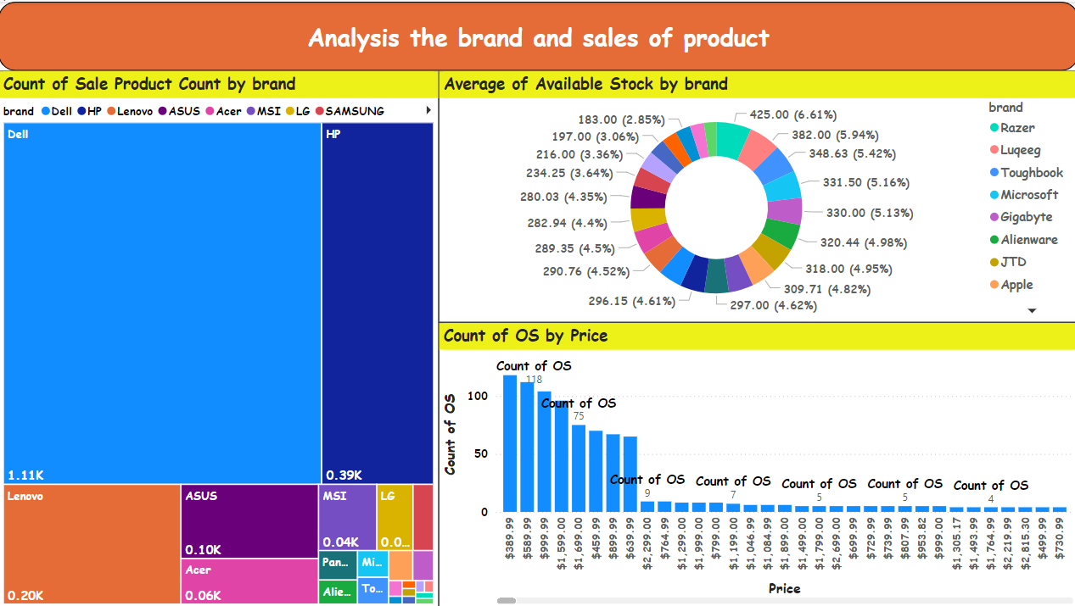

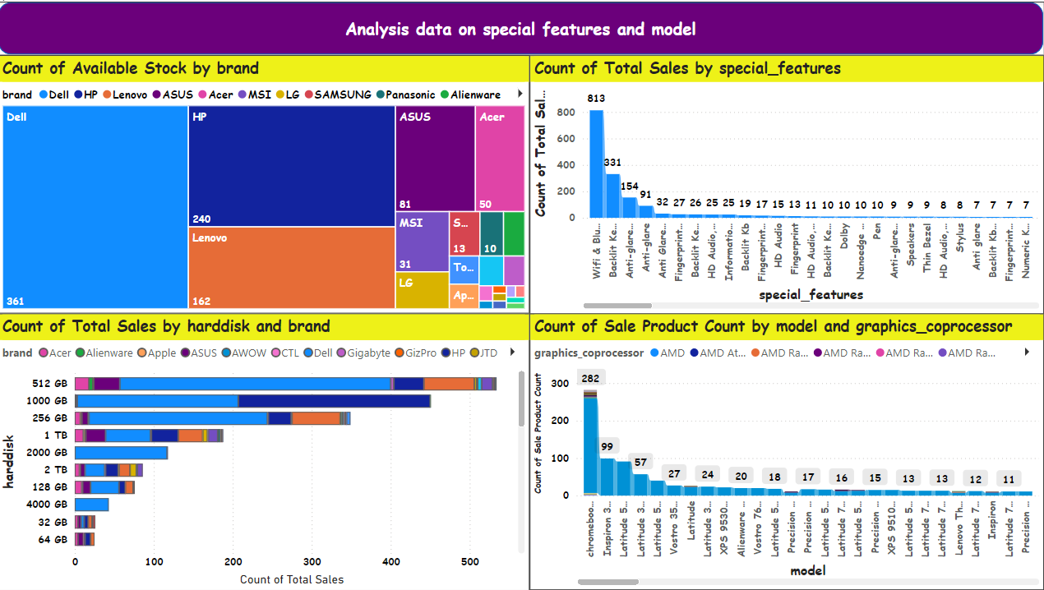

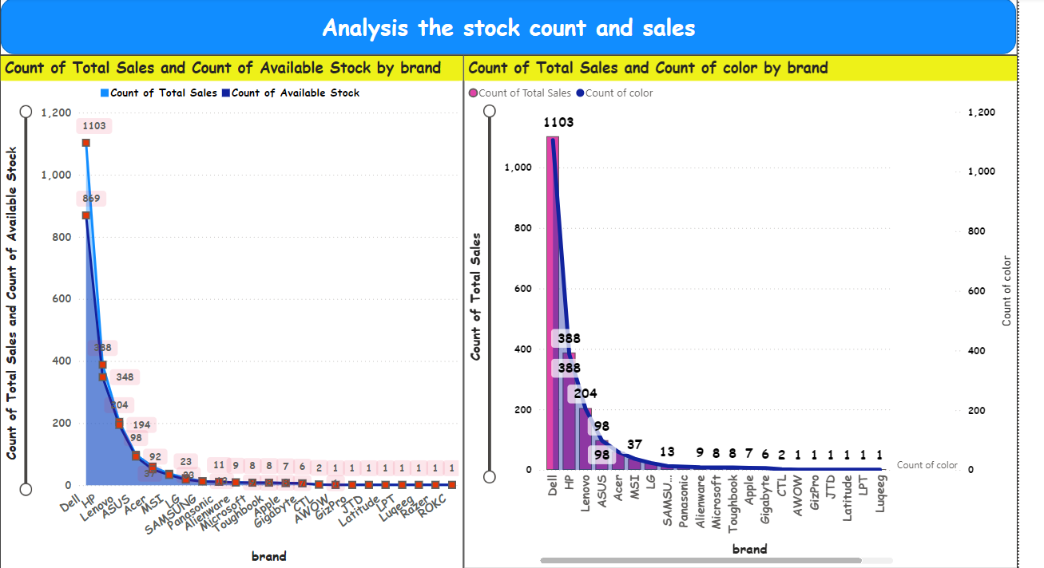

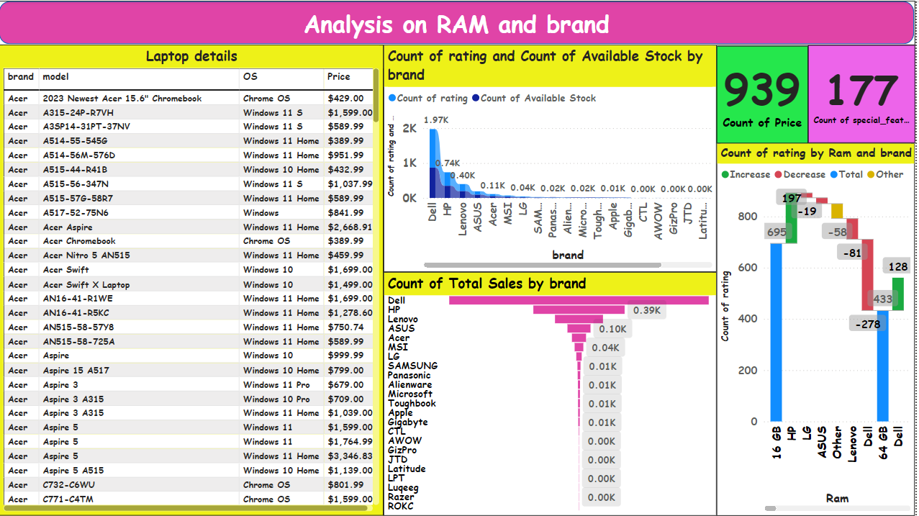

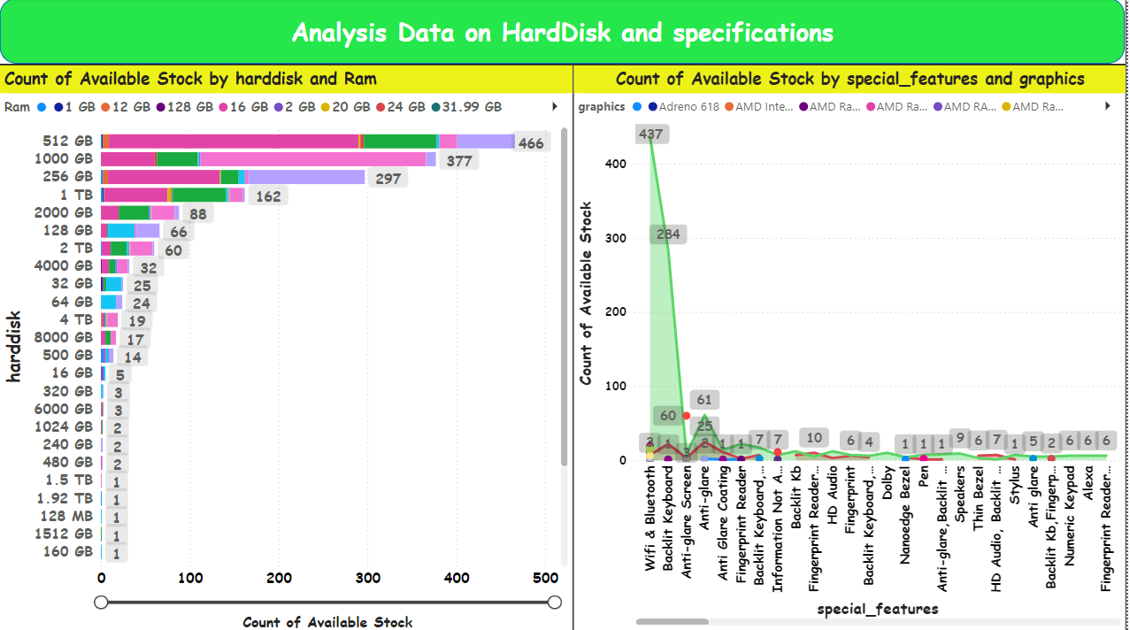

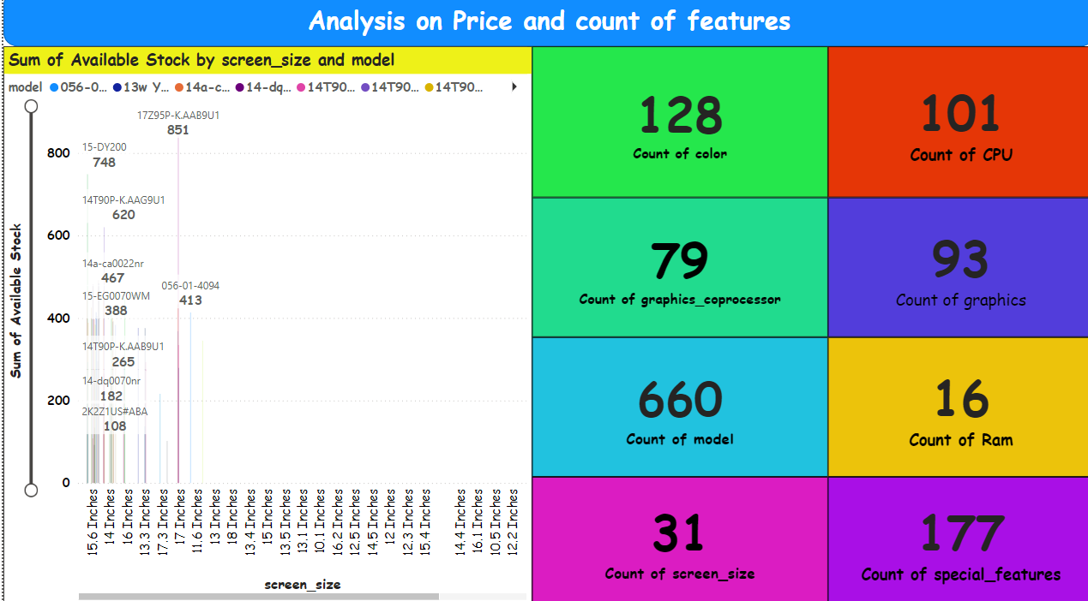

**Conclusion**

**Amazon Laptop sales Dashboard**

* **The Amazon Laptop Sales Dashboard provides valuable insights into sales performance, customer preferences, and market trends.**
* **Key highlights include top-performing brands, best-selling models, price ranges with the highest demand, and geographic distribution of sales.**
* **By leveraging these insights, businesses can make informed decisions on inventory planning, pricing strategies, and targeted marketing campaigns.**
* **Overall, the dashboard serves as a powerful tool for tracking performance and identifying growth opportunities in the competitive e-commerce landscape.**